**Installing Atomic Red Team in Linux**

**Prerequisites:**

* **Linux OS (UBUNTU - my preference)**
* **Powershell Core**

**Step 1: Open Ubuntu and check the version of your OS using the command “cat /etc/os-release | grep PRETTY_NAME”**

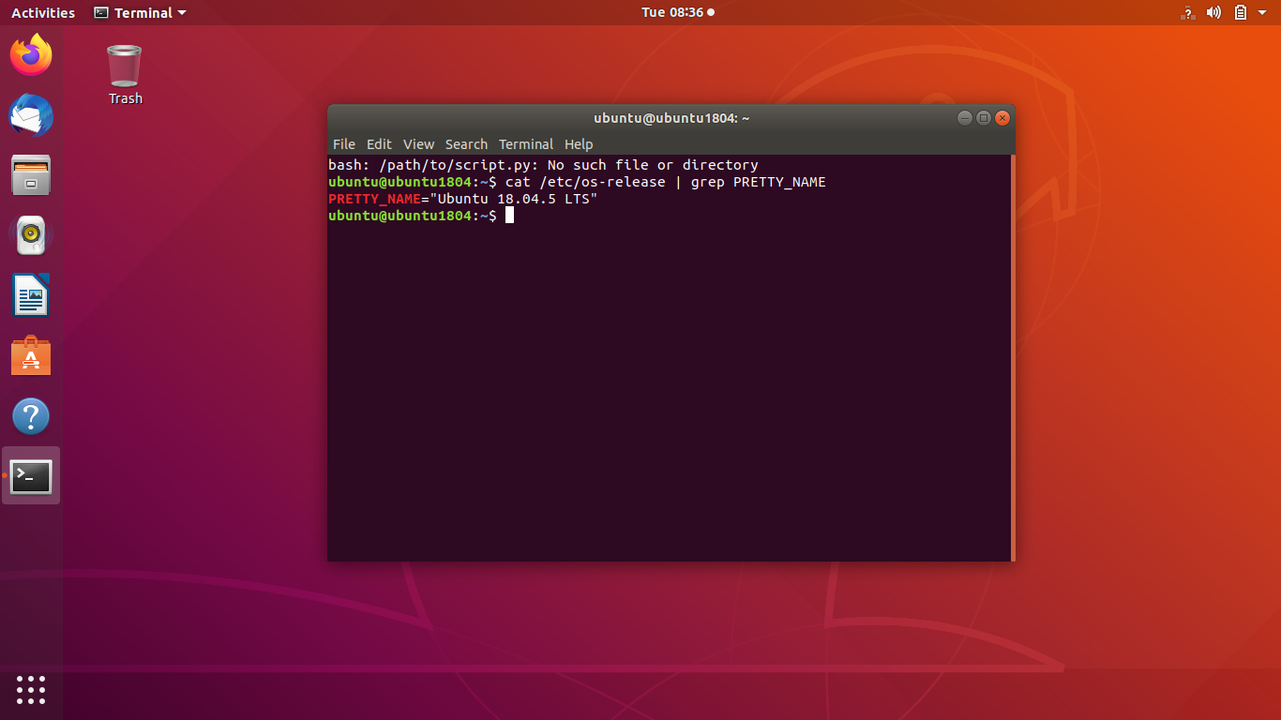

**Step 2: now download the Microsoft repositories that are specific to this release using the command “wget -q** [**https://packages.microsoft.com/config/ubuntu/18.04/packages-microsoft-pro.deb**](https://packages.microsoft.com/config/ubuntu/18.04/packages-microsoft-pro.deb)**”**

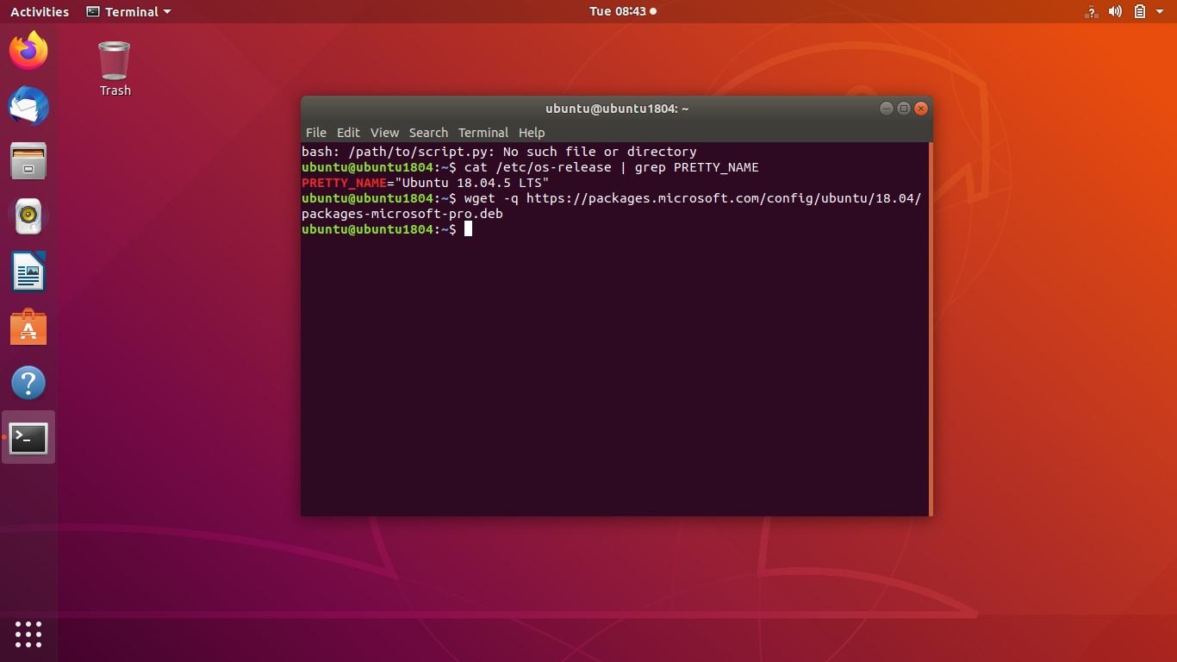

**Step 3: now register the downloaded dpkg using the command “sudo dpkg -i packages-microsoft-prod.deb”**

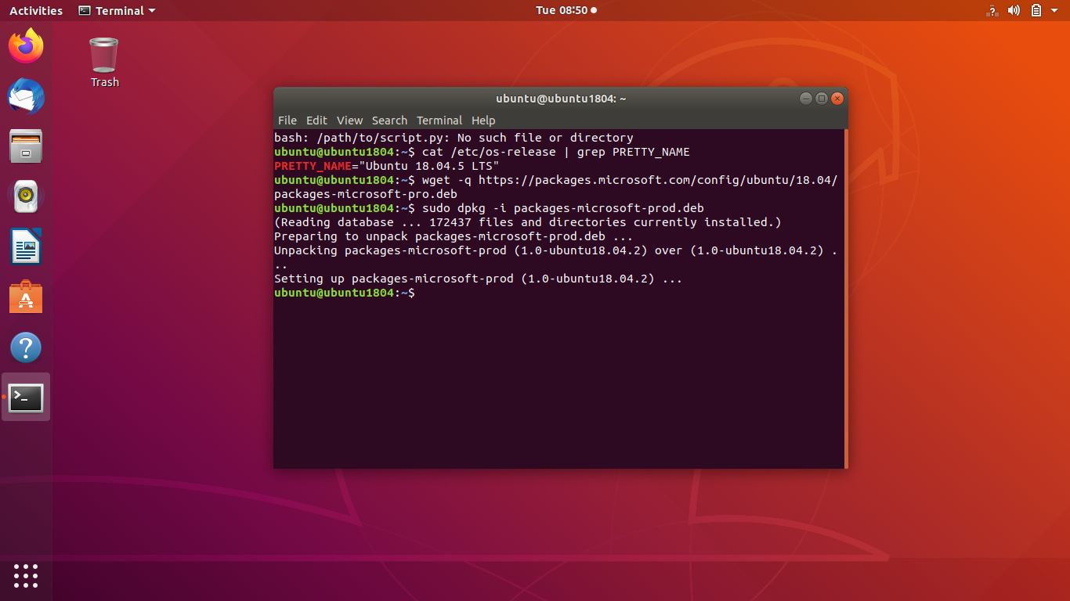

**Step 4: now update the list of products using the command “sudo apt-get update”**

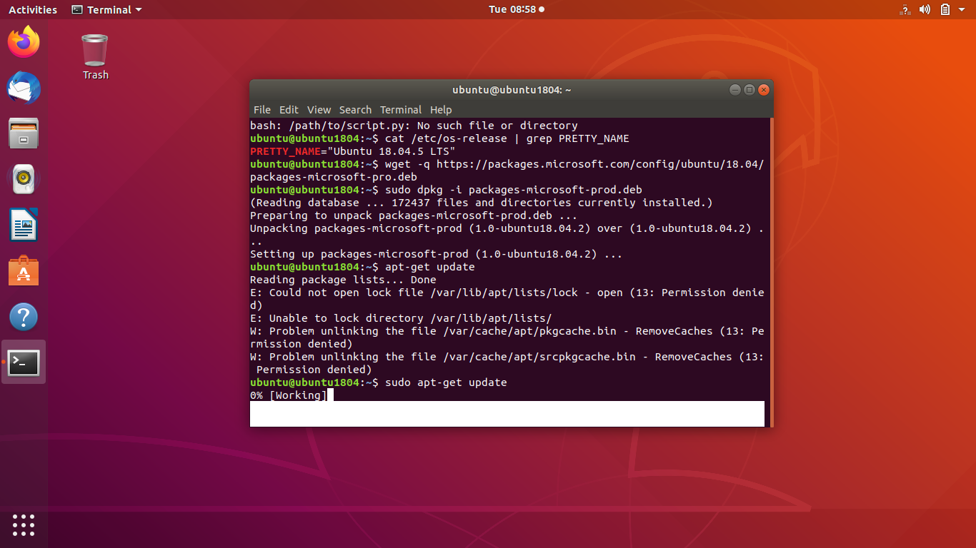

**Step 5: Now install the PowerShell core using the command “sudo apt-get install -y powershell”**

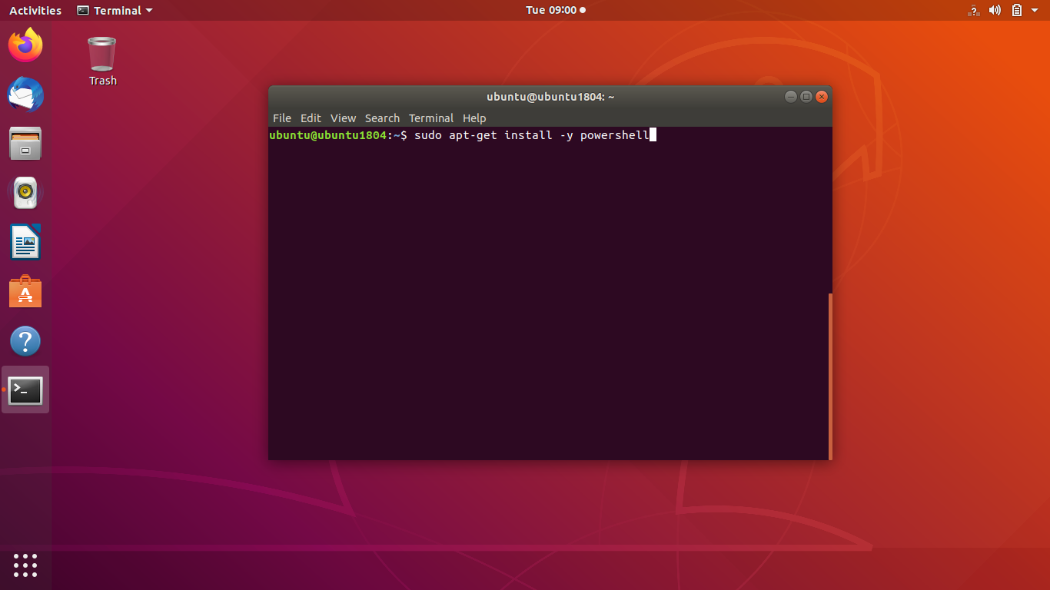

**Step 6: After installing the PowerShell invoke the PowerShell by using the command “pwsh”**

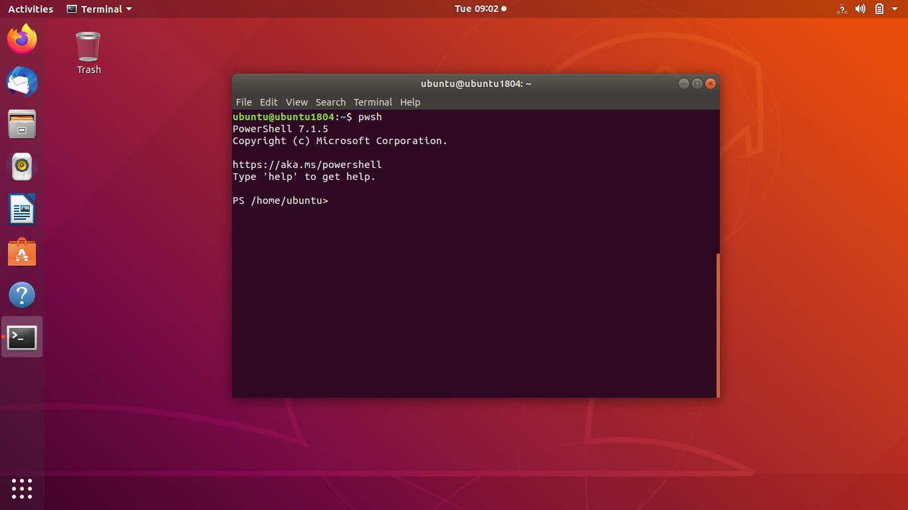

**Hence Powershell Core is installed on our linux machine and now we’ve to install atomic Red Team in our linux using Powershell. It follows the same steps from now on as we follow in the installation of the atomic red team in Windows.**

**Step 7: Go to the Atomic Red Team GitHub page where the installation command is available.**

[**https://github.com/redcanaryco/invoke-atomicredteam/wiki/Installing-Atomic-Red-Team**](https://github.com/redcanaryco/invoke-atomicredteam/wiki/Installing-Atomic-Red-Team)

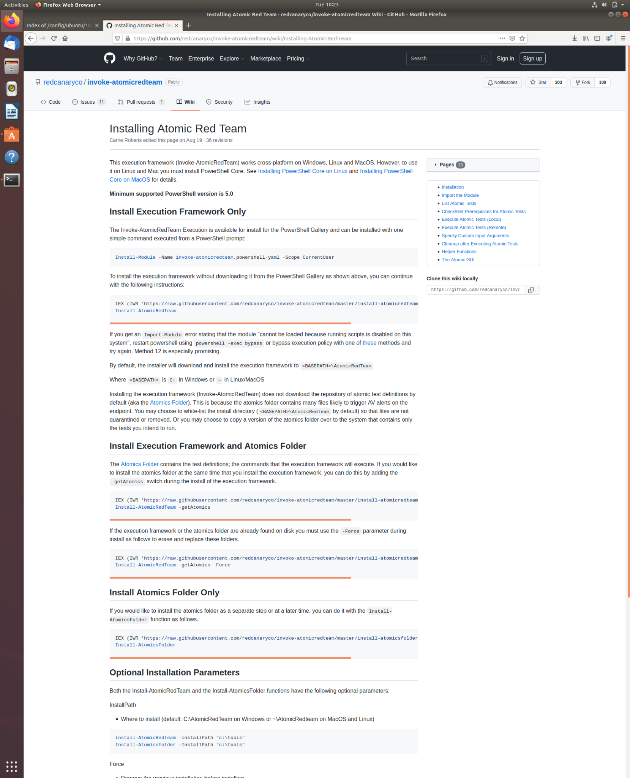

**Step 8:copy the command, and run it in Powershell.**

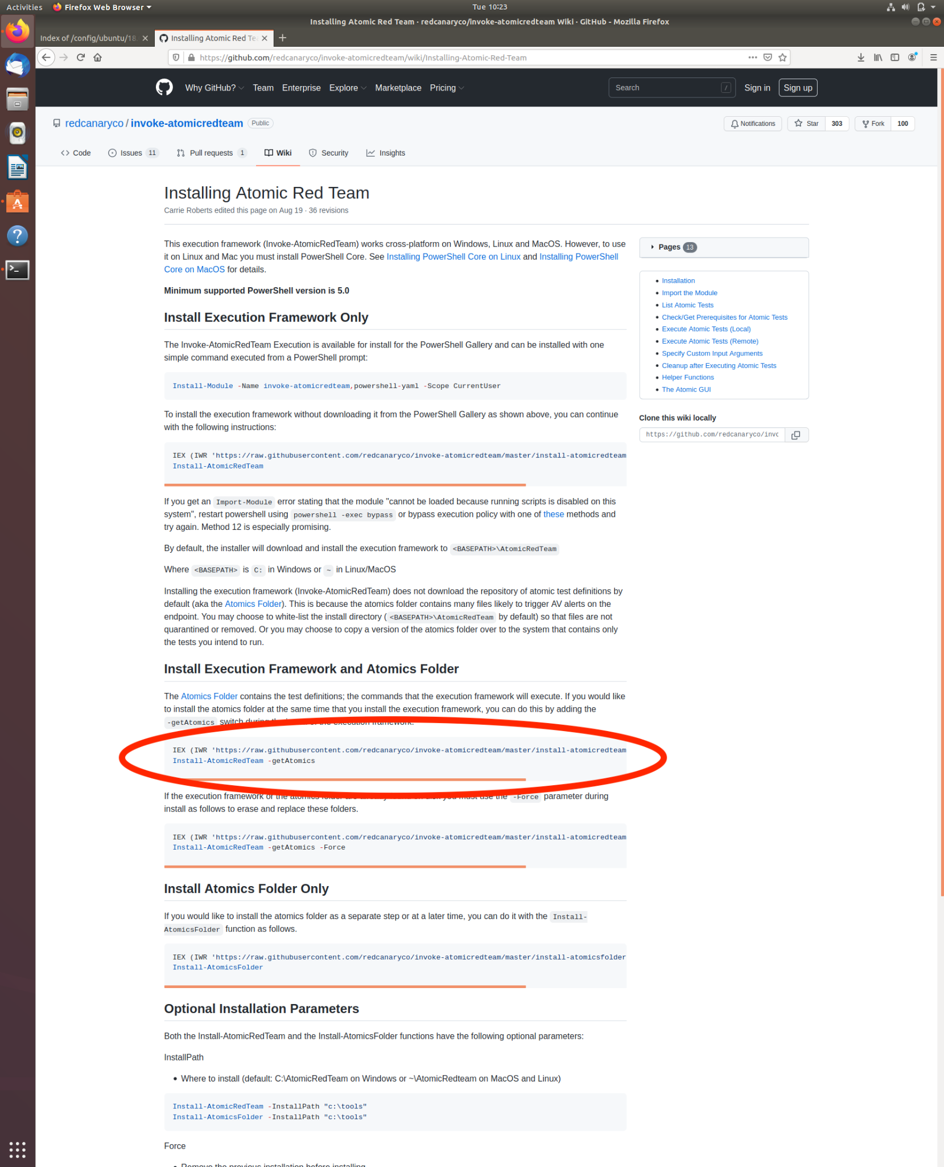

**Step 9: After installation, it should tell you that “Invoke-AtomicRedTeam is complete”.**

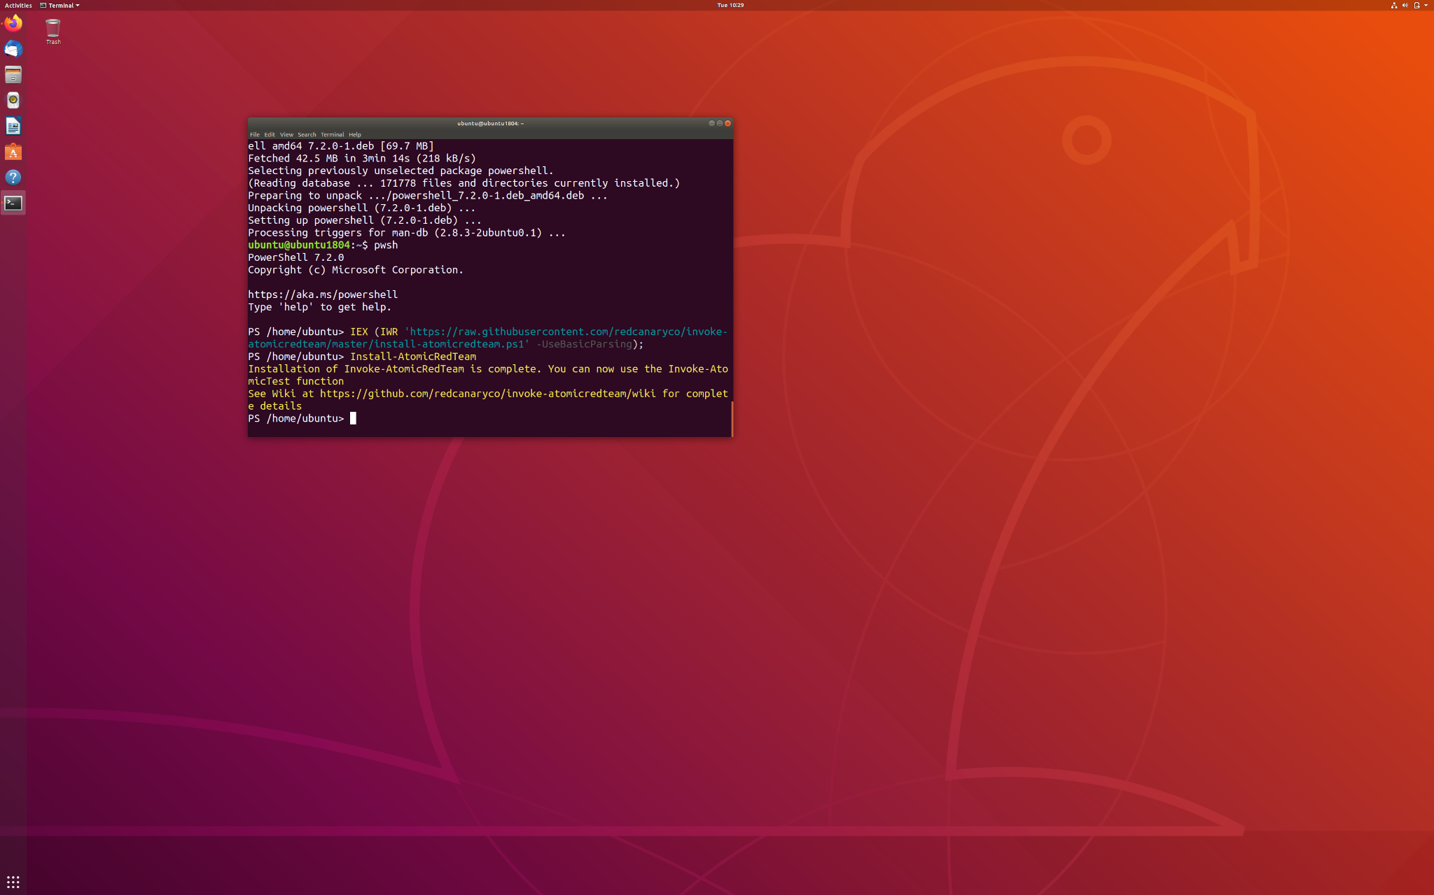

**Step 10: then install the atomics folder by using the command “Install-AtomicredTeam -getatomics” If there is any error, try adding “-force” at the end of the command.**

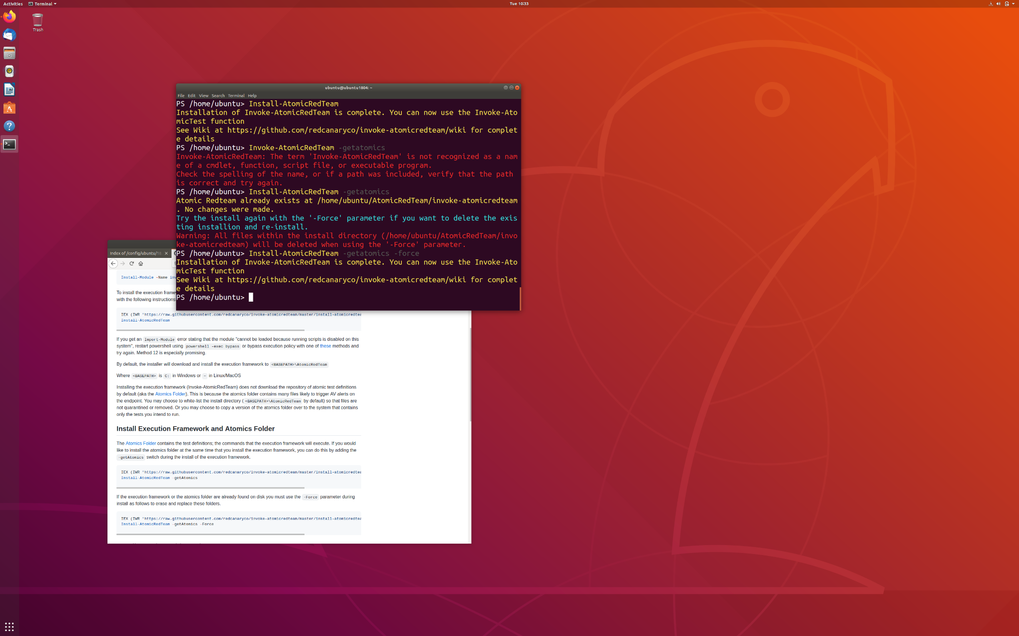

**Now You’re ready with your Atomic Red Team in linux. Use Invoke-Atomictest <Test numbers> syntax to run your atomic tests.**

